# HPE Data Services Cloud Console API usage with Microsoft Powershell

This document describes the Powershell commands of daily tasks used to automate certain tasks using the HPE Data Services Cloud Console (DSCC) API:

* Create Hosts
* Add Hosts to Hostgroups
* Move Hosts to other Hostgroups
* Create Volumesets
* Add Volumes to Volumeset
* Export a Volume
* Delete Volume
* Show exports of Volume
* Show exports for Hostgroup
* Show Capacity
* Show Warning/Errors

The HPE Storage Business Unit is providing an Open API 3.0 description of the HPE DSCC API, that can be used to generate an SDK in the desired script language. This Open API 3.0 description of the HPE DSCC API is the only officially supported API SDK delivery by HP Storage. Hence it is recommended to use the Powershell SDK generated out of the Open API 3.0 description of the HPE DSCC for future script developments.

# Installing the HPE DSCC Powershell SDK

1. Download the OpenAPI generator jar from maven repo:

<https://repo1.maven.org/maven2/org/openapitools/openapi-generator-cli/6.6.0/openapi-generator-cli-6.6.0.jar>

Make sure JRE is installed in your system. I used the [OpenJDK 17.0.8 LTS](https://learn.microsoft.com/en-us/java/openjdk/download) release from Microsoft.

1. Download the DSCC API Specification yaml file (storage-api.yaml) from

<https://console-us1.data.cloud.hpe.com/doc/api/v1/>

1. Execute the following command from the directory where the generator jar file and api yaml files are downloaded.

java -jar .\openapi-generator-cli-6.6.0.jar generate -i .\storage-api.yaml -g powershell -o sdk\dscc-powershell-sdk

               This will generate the SDK in.\sdk\dscc-powershell-sdk directory.

1. To install the PowerShell SDK locally, run the following commands:

```powershell

Build.ps1

Import-Module -Name '.\src\PSOpenAPITools' -Verbose

```

The DSCC Powershell SDK includes a README.md file, that provides a documentation for API Endpoints. The README.md file includes the complete list of DSCC Powershell SDK methods and models. The DSCC Powershell SDK includes 350 methods at the time, this document was written.

# Connecting to the DSCC

You will first need to connect to the DSCC with the appropriate Client ID and Client Secret. The Client Id and Client Secret are used to retrieve the Client ID specific Access Token, that is stored in the global $Configuration PowerShell variable.

Please note:

* The Access Token is valid only for 2 hours (120 minutes). Afterward, you must use the Client ID and Client Secret to obtain a new access token.
* The current Access Token will not be valid anymore (invalidated) after:
  + The associated Client Credential is deleted.
  + User account (resource owner) which is used to create this Client ID/Client Secret is deleted.
  + A new Access Token is created, even though the current Access Token is valid.
* The user can create max 5 API Client Credentials out of a HPE GreenLake user account.
* The GreenLake User account (resource owner) password reset will not invalidate the Access Token.

The Client Credentials can be created using the HPE DSCC user interface. Select the API tile of the HPE GreenLake Manage page:

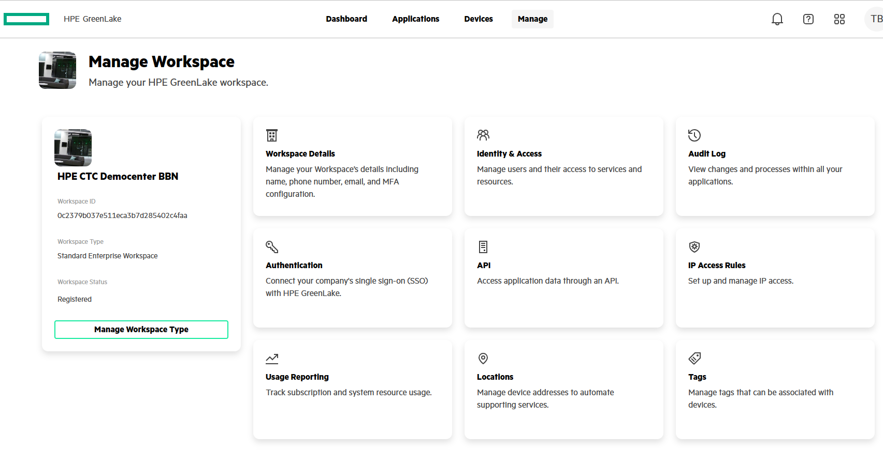

Select the Create Credentials button to create your credentials.

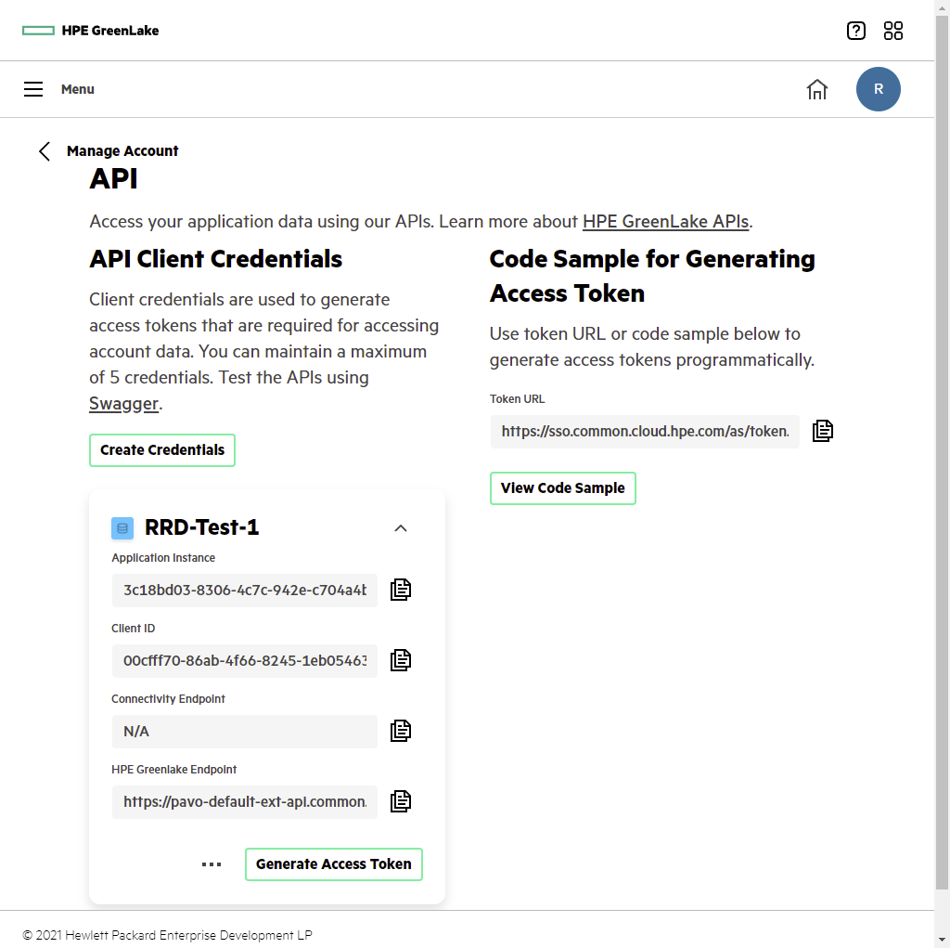

# Daily task list

The code snippets are provided in separate files with PowerShell code snippets.

| Task | Code |
| --- | --- |
| Get a DSCC Connection | Task_0_GetConnection.ps1 |
| Create a Host | Task_1_CreateHost.ps1 |
| Add Hosts to Hostgroup | Task_2_AddHostToHostGroup.ps1 |
| Move Hosts to other Hostgroup | Task_3_MoveHostsToOtherHostGroup.ps1 |
| Create Volumesets | Task_4_CreateVolumeSets.ps1 |
| Add Volumes to Volumeset | Task_5_AddVolumesToVolumeSet.ps1 |
| Export a Volume | Task_6_ExportVolume.ps1  Task_6b_ExportVolumeSet.ps1 |
| Delete a Volume | Task_7_DeleteVolume.ps1  Task_7b_DeleteVolumeSet.ps1 |
| Show Exports of a Volume | Task_8_ShowExportsOfVolume.ps1 |
| Show Exports of a Hostgroup | Task_9_ShowExportsOfHostGroup.ps1 |
| Show Capacity | Task_10_ShowArrayCapacity.ps1 |
| Show Warning/Errors | Task_11_ShowWarningsErrors.ps1 |
| Get Current Systems, Hosts etc. | Task_12_GetCurrentData.ps1 |